**Guide to use   
  
Real Time Biosemi**

**Please, report any bug to Ale Presacco (pressalex@hotmail.com)**

**Table of Contents**

Introduction1

Part I2

Start the GUI2

Parameters TCP/IP3

Parameters EEG Data 13

Subsection: Parameters Biosemi13

Subsection: IIR Filter21

Subsection: Parameters Display Data23

Plot the Data28

Establish the connection with the server29

Display the Data34

Close the connection36

Remarks on plotting large number of samples37

Part II40

Non-standard libraries40

Configuration of the bytes sent by Biosemi41

Calibration factor41

Demean the data42

IIR Filter42

FFT42

**Introduction**

This document provides a quick and simple guide to use the Real Time Biosemi GUI. It is divided into two main parts:

1. The first part describes the basic steps to set up the parameters and to run the GUI.
2. The second part offers basic technical details about the code.

The code can be download from github: <https://github.com/InterTriplete2010/Real-Time-GUI-to-read-EEG-Biosemi-data>

The executable file ***Real_Time_Biosemi_Cpp*** is located in x64 -> Release

**Part I**

**Start the GUI**

When the user starts the application (file named ***Real_Time_Biosemi_Cpp***), the GUI will pop up with default parameters that will be described in the following pages.

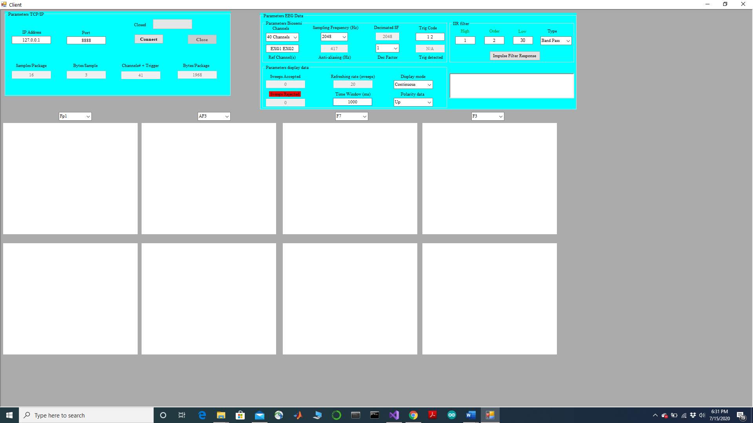

**Parameters TCP/IP**

This TCP/IP (***transmission control protocol/Internet protocol***) box contains the parameters used to establish a connection with Biosemi. It is critical to understand that since Biosemi acts as a server, the connection cannot be established unless the Biosemi system is running, in either the display or the recording mode. Furthermore, the user needs to make sure that the parameters in the TCP/IP box matches the parameters set-up in Biosemi.

The parameters in Biosemi are located in the ***TCP server*** tab and need to be adjusted before running Biosemi. They cannot be changed after Biosemi has started acquiring data, even if it is in display mode. The figure below shows how the ***TCP server*** looks like when the user opens Biosemi and data are not being collected.

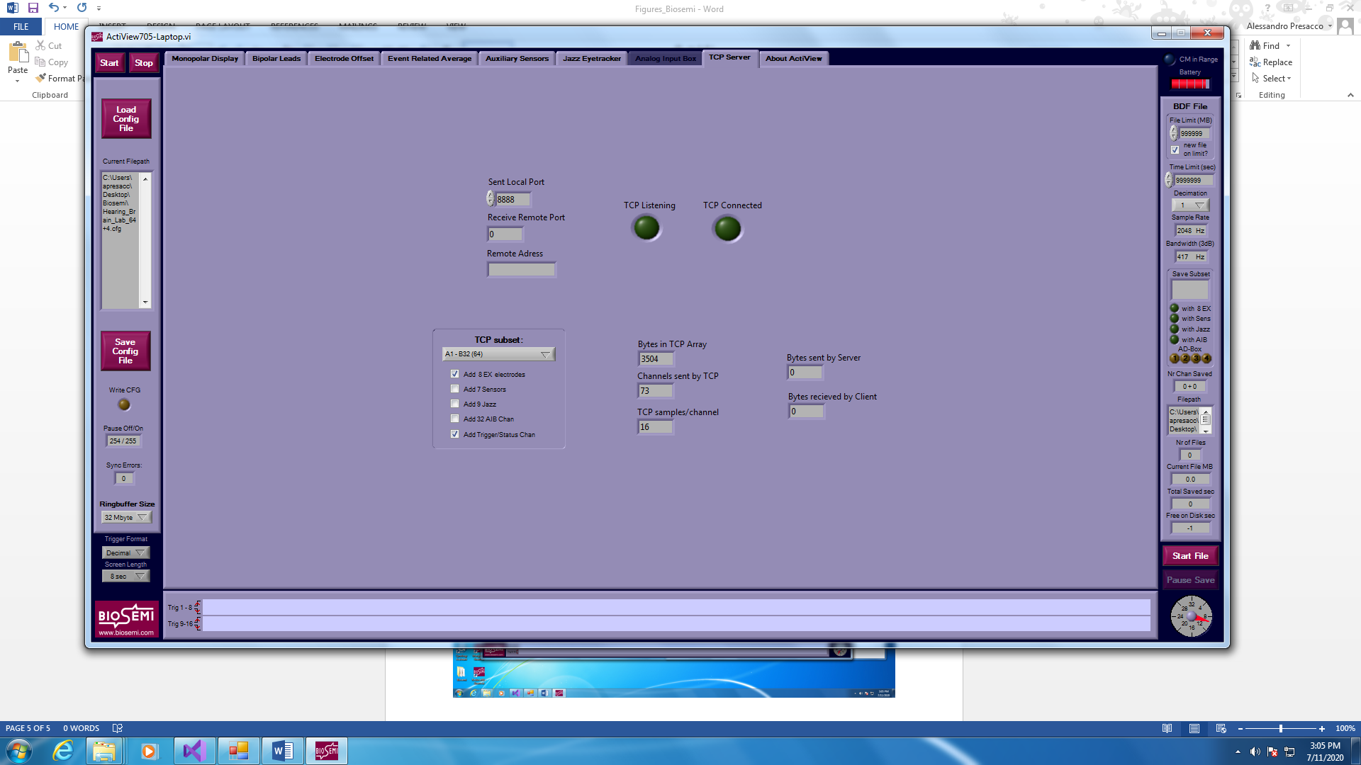

* ***IP address:*** if the GUI is installed in the same computer used to run Biosemi, the value in the GUI needs to be ***127.0.0.1.*** Otherwise, the ip address needs to be the one of the computer where Biosemi is running on. No need to make any change in Biosemi.
* ***Port:*** This is the port used to communicate. It needs to match the one reported in Biosemi, which is ***8888*** by default.



* ***Samples/Package:*** This is the number of samples contained in each package of data sent by Biosemi. It depends on the sampling frequency selected by the user.



* ***Bytes/Sample:*** This is the number of bytes used by Biosemi to represent each sample. It is fixed regardless of the sampling frequency and it cannot be changed by the user.



* ***Channels# + Trigger:*** This shows the number of channels selected by the user plus the trigger. It is controlled by the item ***Channel***, which will be described in the section dedicated to ***Parameters EEG Data*** (subsection: ***Paramters Biosemi***). This value must match the one reported in Biosemi.



* ***Bytes/Package:*** This is the number of bytes contained in each package of data sent by Biosemi. It depends on the sampling frequency selected by the user.





* ***Connect and Close button and the progress bar*** will be discussed in pages 32-34 and page 39

**Parameters EEG Data**

* ***Subsection: Parameters Biosemi***
* ***Channels:*** The user can choose to have 40 channels, 72 channels or a number of customized channels. The choice needs to match the set-up in Biosemi



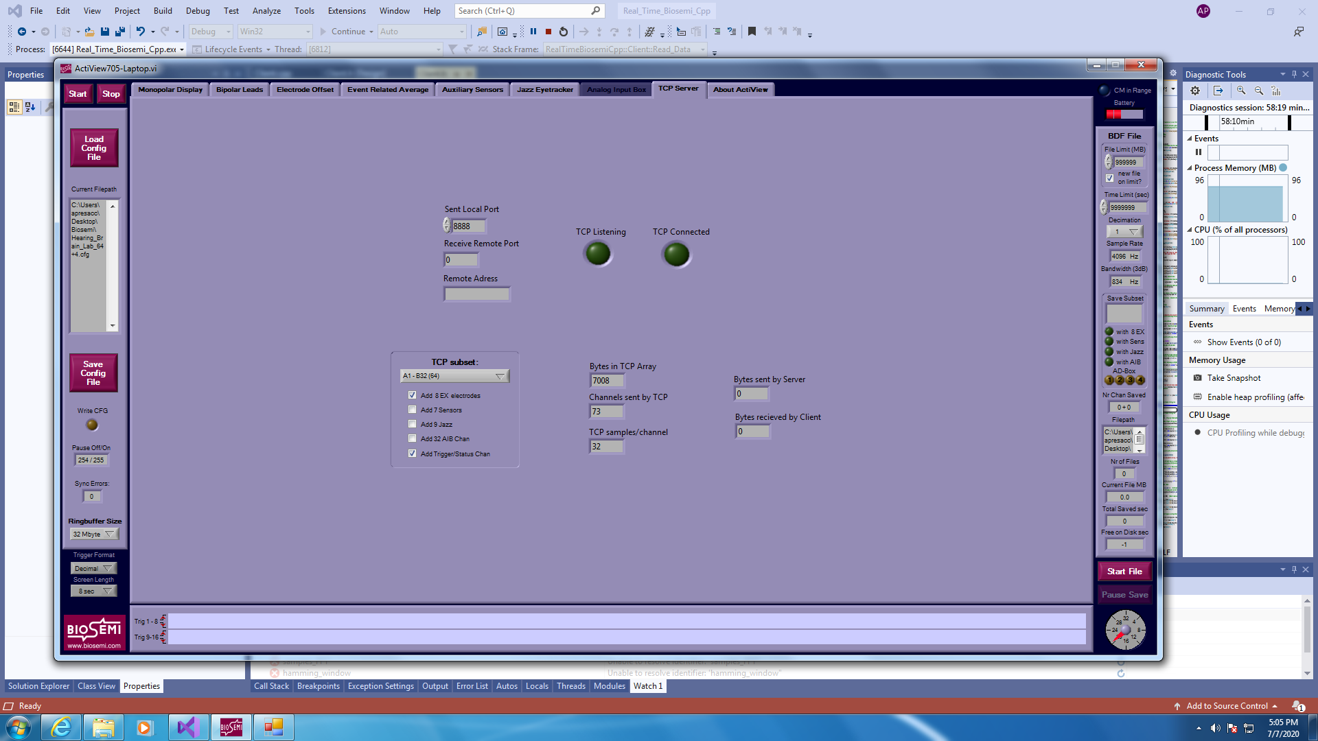

If the user selects a customized number of channels, a new window will pop up. The user will have to check the channels that need to be used. A minimum of 2 channels needs to be selected, because one of them will serve as reference. In order to finalize the selection, the user needs to close the new window.

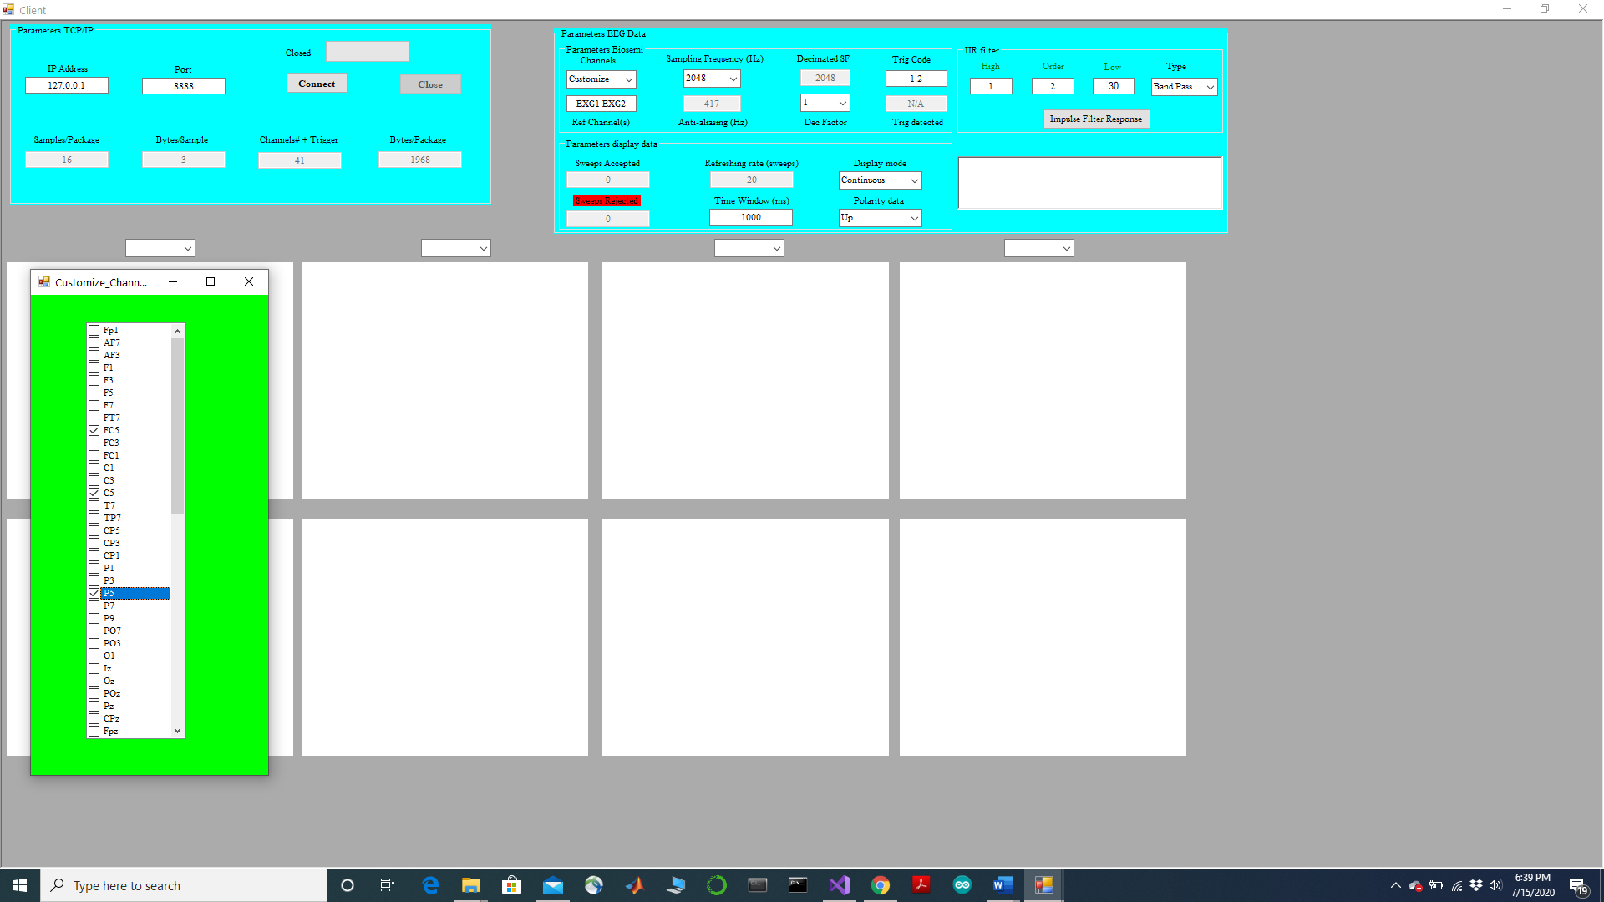

* ***Sampling Frequency Hz:*** The user can choose between 4 different sampling frequencies (2048, 4096, 8192 and 16384). The text box right below the sampling frequencies (***Anti-aliasing (Hz)***) represents the cut-off frequency of the anti-aliasing filter applied by Biosemi. In the figure below, the frequency selected was 4096 Hz and the cut-off frequency of the anti-aliasing filter is 834 Hz. The sampling frequency selected needs to match the one used in Biosemi.



* ***Dec Factor:*** The user has the option to decimate the data to improve the speed of the GUI. It is important to point out that the decimation occurs after the data have already been collected. In order to avoid aliasing, the user has 3 choices: 1 (no decimation), 2 (decimation by a factor of 2) and 4 (decimation by a factor of 4). The box above the decimation factor (***Decimation SF***) shows the sampling frequency after being decimated. The use of the decimation factor is highly recommended when collecting data at high sampling frequencies, such as 8192 and 16384 Hz. It is also highly recommended at lower sampling frequencies, if sweeps of long duration (e.g. > 1 seconds) are collected.



* ***Trig code:*** The user can select as many trigger codes as he/she wants. However, the GUI won’t differentiate across them, that is each time a trigger code selected by the user is detected, the average will be updated. The box below the trigger code (***Trig detected***) will display all the codes, even the ones not selected by the user, detected by Biosemi.



* ***Ref Channel(s):*** The user needs to select at least one valid reference channel across the channels available. If more than one is selected, the GUI will average the ***N channels*** selected. When the user attempts to insert new names, the box will turn red, indicating that the selection has not been finalized. The user needs to press ***enter*** to finalize the choice. If one or more names are not valid a message will inform the user that the selection is not valid and that changes need to be made.



* ***Subsection: IIR Filter***
* ***High, Order and Low:*** these three boxes allow the user to specify the corner frequencies of the Butterworth filter used to filter the data.
* ***Type:*** This drop-down menu allows the user to choose the type of filter to be applied to the data.



* ***Impulse Filter Response:*** by clicking here, the user can plot the impulse filter response in the frequency domain of the selected filter. The legend will also inform the user on the stability of the filter. In the example below, the impulse filter response is display for a band-pass filter and the filter results to be stable.

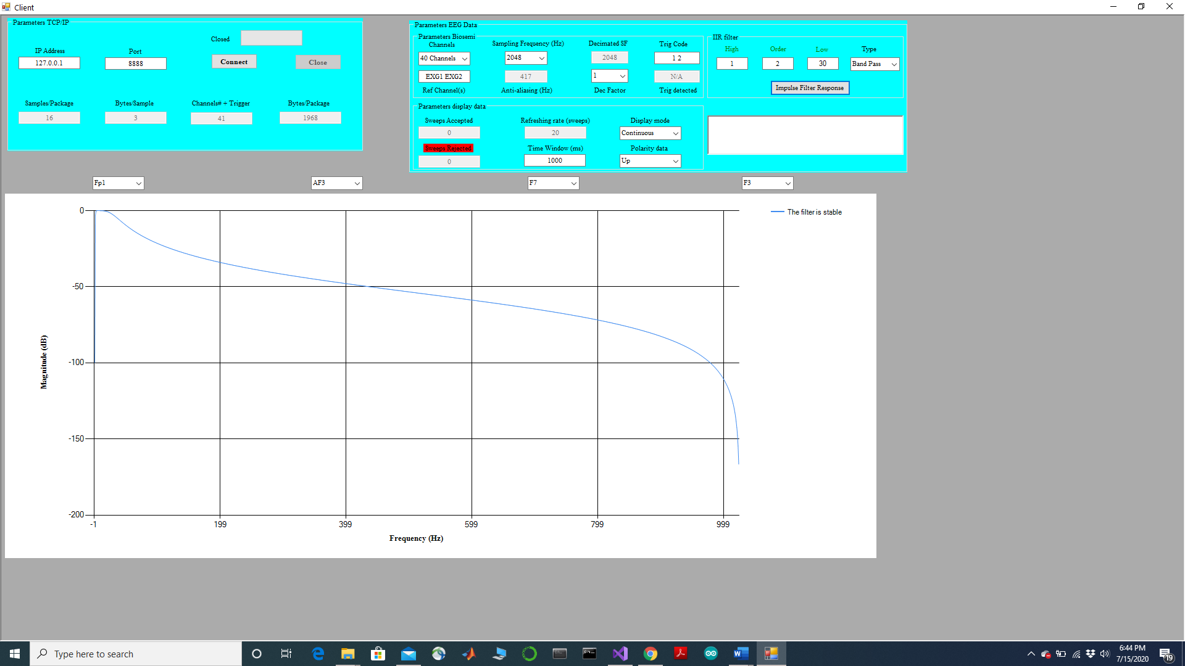

* ***Subsection: Parameters Display Data***
* ***Data type:*** The user can select between two operating modes:

* + - The ***continuous*** mode means that the data will be visualized every ***N ms*** (the selection of the window will be discussed below) without being averaged. In this mode, the selection of the triggers won’t have any effect.
    - The **average** mode means that the sweeps will be averaged if a trigger is detected if the amplitude is within the artifact rejection threshold, which will be discussed below. Data will not be displayed unless at least 1 trigger is detected, and 1 sweep meets the artifact rejection threshold.



* ***Sweeps accepted and sweep rejected:*** These two boxes show the number of sweeps accepted and the number of sweeps rejected, respectively. The values will be updated only when in a ***average*** mode



* ***Refreshing rate (sweeps):*** This box is used to determine the refreshing rate of the average. For instance, if the user chooses 20, as in the figure below, the average will be plotted every time 20 sweeps are accepted. This box is disabled in ***continuous*** mode, as data are continuously collected, regardless of the presence of a trigger



* ***Time window (ms):*** This box is used to determine the length of each sweep in the ***average*** mode. In ***continuous*** mode, this box is used to determine the refreshing rate of the data.



* ***Polarity data:*** This box is used to determine the polarity of the data. ***Up*** means that data are plotted with polarity determined by ***chan – ref***, while ***Down*** means that data are plotted with polarity determined by ***ref – chan***.



* ***Plot the data***
* The GUI allows the user to plot the time and frequency response of up to four channels. The channels available will be shown in four different drop-down menus.
* The figures in the top row show the neural activity in the time domain, while the bottom row the neural activity in the frequency domain.



**Time Domain**

**Frequency Domain**

* ***Establish the connection with the server***
* After all the parameters have been set correctly, the user can establish a connection with the server.
* When the user starts collecting data, the ***TCP Listening*** round icon will turn green, thus signaling that Biosemi is ***listening*** and is ready to establish a connection.

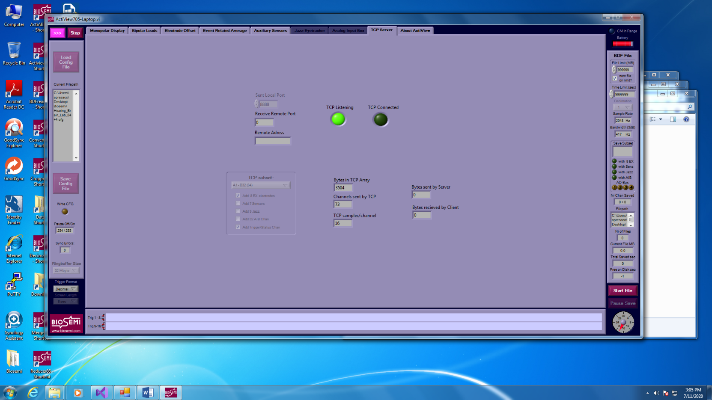

* The user is now ready to click the ***Connect*** button, which is located in ***Parameters TCP/IP*** box.
* If the connection is successful, the progress bar in the GUI will turn green, the text right next to the progress bar will change to ***Open*** and the ***Close*** button will be enabled, thus allowing the user to terminate the connection.
* In Biosemi, the the ***TCP Connected*** round icon will turn green, thus signaling that Biosemi is transmitting data to the GUI. The number of bytes received and transmitted are also reported in Biosemi
* Additionally, the box right below the subsection ***IIR Filter*** will show the following messages:
  + Connecting to the server... - Time: 15:20:10
  + Connection to the server established - Time: 15:20:10
* When the connection is established, the parameters are disabled and cannot be changed until the connection is terminated. During recording, the user will only be able to modify the ***artifact rejection threshold*** and the ***range of the frequency domain***, which will be discussed in 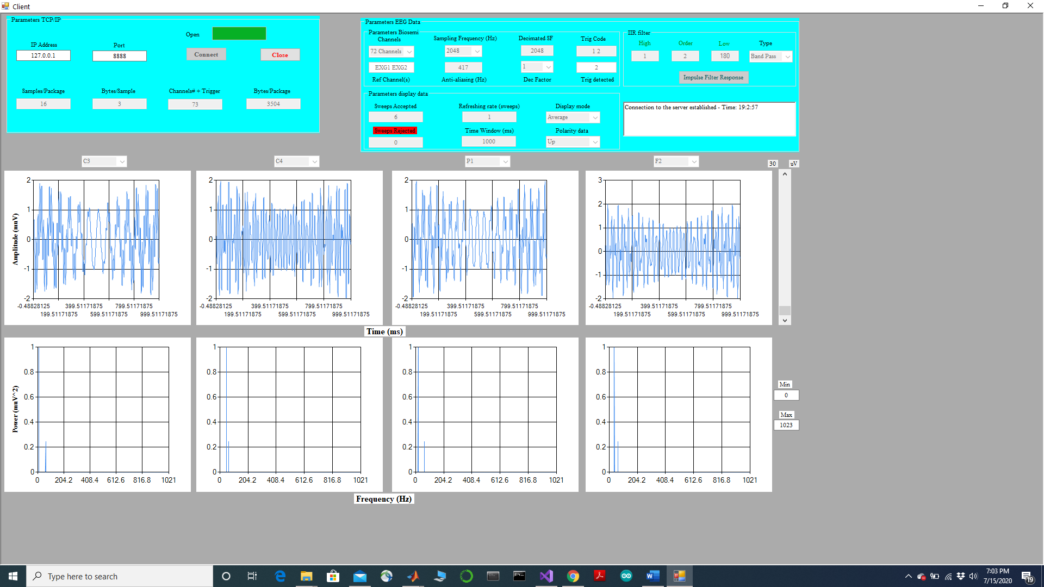pages 40-41).

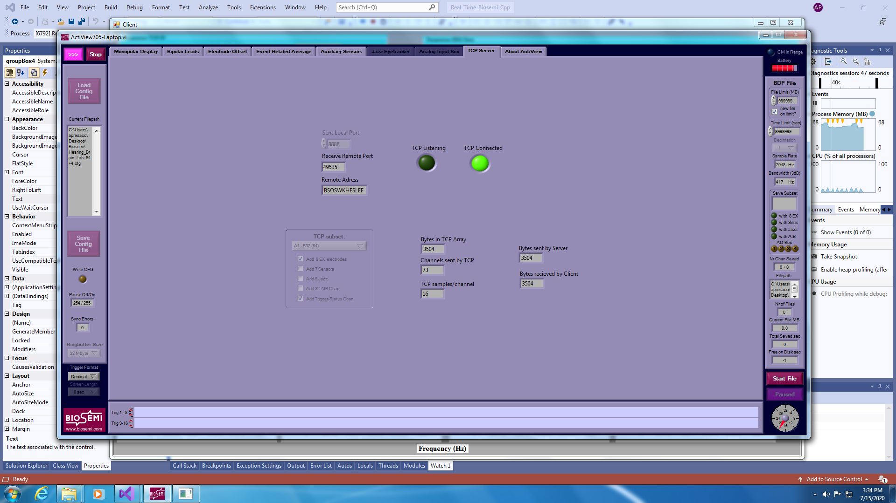

* If there are problems with the connection, the GUI will re-try for a few seconds to connect to the server. If the connection ultimately fails to be established, an error message will be displayed

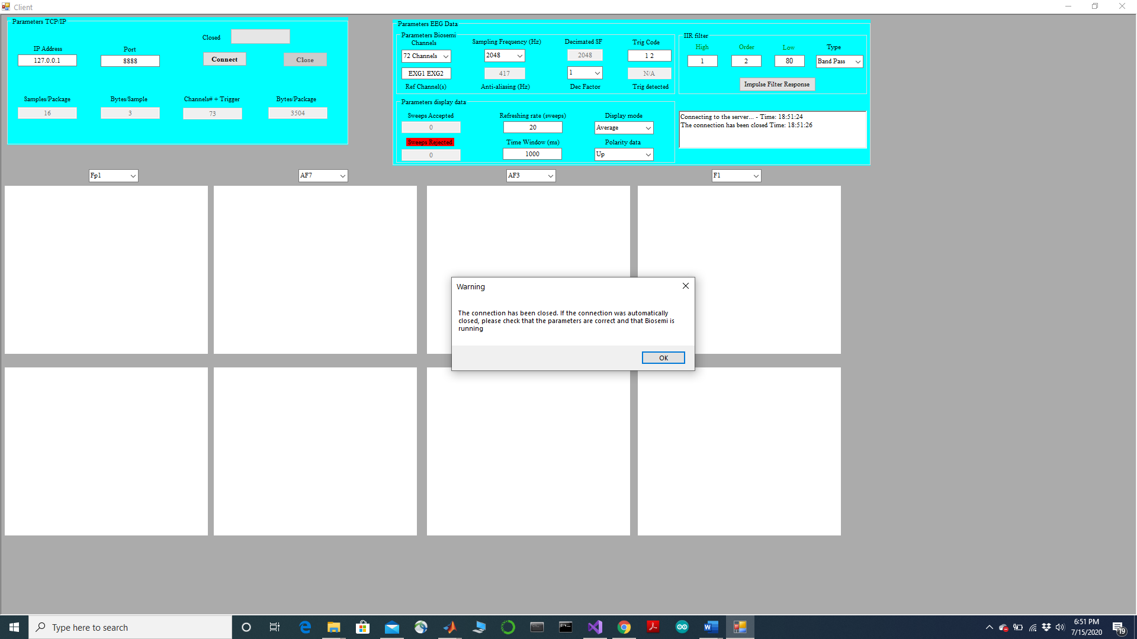

* ***Display the data***
* The figures below show an example of how data will look like. In this case, four different sinusoidal waveforms are plotted in the time and frequency domain.
* The user can change the artifact rejection threshold by move up and down the sliding bar on the right end-side.

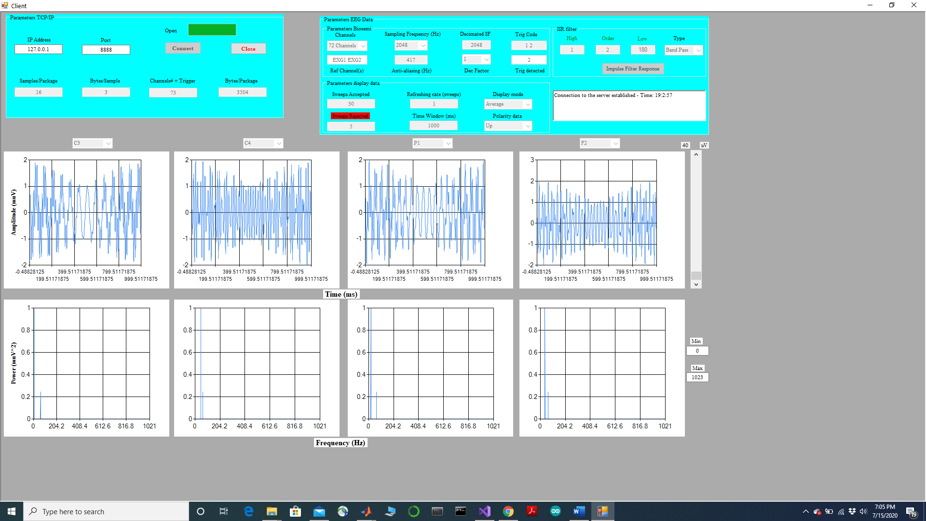

* The user can change the range of the x-axis of the frequency domain in order to better visualize specific peaks.

* The user can also move the cursor to visualize the values of the x and y axis both in the time and in the frequency domain

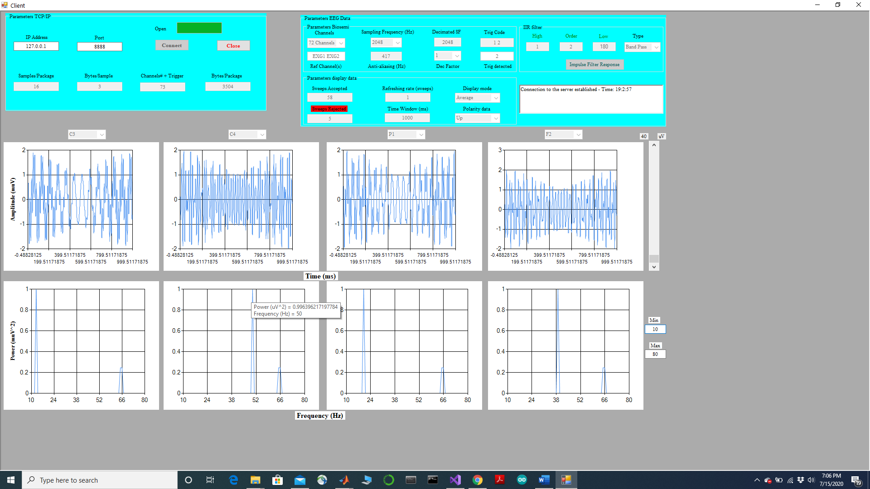

* ***Close the connection***
* The user can terminate the connection by clicking the button ***Close*** located in ***Parameters TCP/IP.*** A message will show up informing the user that the connection has been terminated.
* Additionally, the box right below the subsection ***IIR Filter*** will show the following messages:
  + The connection has been closed Time: 15:56:38

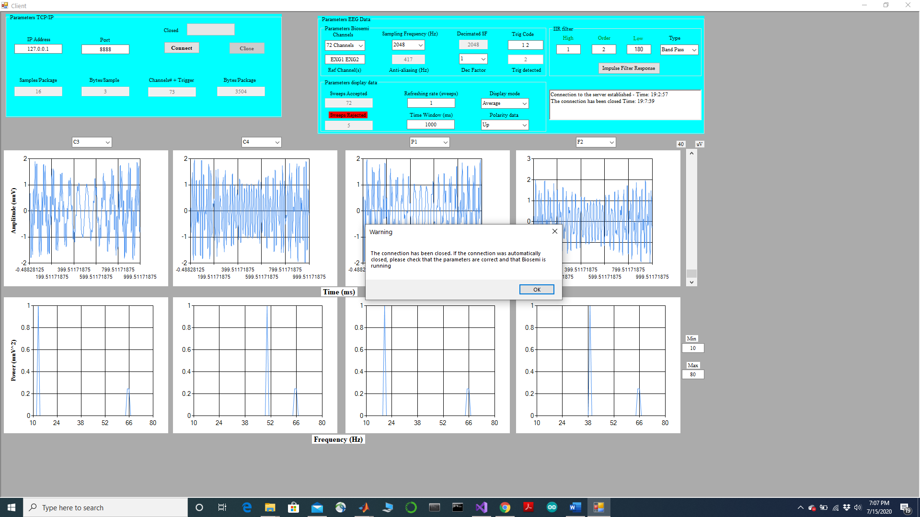

* ***Remarks on plotting large number of samples***
* A critical limitation of this program is its ability to plot a large number of samples, without causing loss of packages of data and/or problems across threads that may lead to the GUI to freeze. ***Decimation*** of the data was added to specifically address this problem. Importantly, the integrity of the analysis won’t be compromised by decimation, because of the anti-aliasing filter applied by Biosemi on the data. Here are a few tips on when to use it.

1. If the user selects a sampling frequency of ***2048 or 4096 Hz*** and the ***time window*** is no longer than ***1 second***, there is no need to use any decimation. If the time window is longer than 1 second, a ***decimation factor of 2 or 4*** is strongly recommended.
2. If the user selects a sampling frequency of ***8192 Hz***, no decimation factor is necessary for time intervals =< 500 ms. For time intervals > 500 ms a decimation factor of 2 is recommended.

If the user selects a sampling frequency of ***16384 Hz***, a decimation factor of 2 is recommended for time intervals =< 500 ms, while for time intervals > 500 ms a decimation factor of 4 is strongly recommended. In the continuous mode, the user should always use a decimation factor of 4. If very short time windows are used (~20 ms), no need to use any decimation factor.

1. a ***decimation factor of 4*** is strongly recommended, regardless of the ***time window*** chosen.

**Part II**

* ***Non-standard libraries***

Three non-standard libraries were used to develop this GUI:

1. ***Armadillo (***<http://arma.sourceforge.net/>***)***: this library is for linear algebra & scientific computation. If used with VS2019 environment, the following two lines of code need to be used:

#define ARMA_DONT_USE_CXX11_MUTEX

#include <armadillo>

1. ***Sigpack (***<http://sigpack.sourceforge.net/>**):** this is a signal processing library.
2. ***IIR_Butterworth****(*<https://github.com/InterTriplete2010/IIR_Butterworth_Filter_Cpp>***)***: this library calculates the coefficients of the IIR Butterworth filter and evaluate its stability. It was written by following the same steps as described in Matlab.

* ***Configuration of the bytes sent by Biosemi***

Each sample is represented by 3 bytes, using a little Endian system with two’s complement. Data are transmitted by first sending the first sample of each channel, then sending the second sample of each channel, etc.

A comprehensive description of the configuration of the data can be found on the Biosemi web-site: <https://www.biosemi.com/faq/file_format.htm>.

* ***Calibration factor***

24-bit data read by the GUI are cast into 32 bits. Because of this additional operation the calibration factor will there be 1/32*256, where 32 is the gain and 256 is due to the left shift caused by casting data into 32 bits.

* ***Demean the data***

Raw data transmitted by Biosemi are not filtered. In order to minimize the edge effect due to filtering and due to the presence of the DC component, data are demeaned before being filtered.

* ***IIR filter***

Data are filtered by using Butterworth coefficients. Filtering is accomplished by using a ***Direct-Form II Transpose Filter Block***, consistent with what Matlab uses.

* ***FFT***

The FFT is calculated by using the radix-2 algorithm. When necessary, zero-padding is applied to ensure that the number of samples is a power of 2.